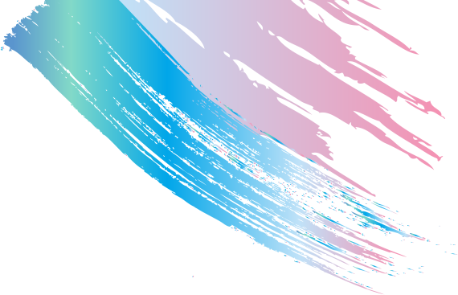

Marjan Design

EMMA SMITH

A close up of a logo

Description generated with very high confidenceA close up of a logo

Description generated with very high confidenceA close up of a logo

Description generated with very high confidence

**SQL | UCLA**

2017 - 2018

**BA in Multimedia| TV University of London**

2002 - 2006

**HND in Interactive Media | HWL College in London**

2000 - 2002

EDUCATION

LANGUAGES

English

Farsi

Software SKILLS

HTML & CSS  
  
PhotoShop  
  
Illustrator  
  
AfterEffects

Hello,

My name is Marjan Aghal. I’m a graphic designer and frontend developer in LA. I specialize in web design, development, user experience, creating identities and branding. I’ve worked with companies of all shapes and sizes; please contact me if you’d like to work together on your next project or if you need an in house designer. Thank You

+31 0 990 1222  
  
INFO@MARJANDESIGN.COM  
  
BEVERLY HILLS | CA | 90212  
  
WWW.MARJANDESIGN.COM

PROFESSIONAL PROFILE

CONTACT



A close up of a logo

Description generated with very high confidenceA close up of a logo

Description generated with very high confidenceA close up of a logo

Description generated with very high confidenceA close up of a logo

Description generated with very high confidence

Problem  
Solving

Mr. Ian Taylor - FairFX  
+44 20 7778 9300

Mr. ED Alizadeh - PacWest  
Ealizadeh@pacwest.com

Ms. Parie Rezaei - PRArt  
0949 701 9936

**PacWest | 2019 - NOW**

Digital Designer & Web Developer

**Parie Rezaei Art| 2018 - 2019**

Graphic Designer & Web Developer

**Build The Store-MYP | 2015 - 2018**

Senior Digital Designer & Web Developer

**L’Oréal-SalonCentric | 2012 - 2015**

Senior Digital Designer & Web Developer

**AT&T-YellowPages | 2010 - 2012**

Graphic Designer & Ad Specialist

**FairFX London | 2006 - 2010**

In House Graphic Designer & Web Developer

**Radio XFM | 2005 - 2006**

Game Designer

Time  
Management

Communication

Reliability

Personal SKILLS

Marjan Design

INTERESTS

* Drawing
* Reading
* Cooking
* Boxing
* Travelling

REFERECES

CERTIFICATES

Best Logo Design in 2016

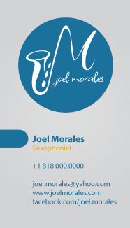

EXPERIENCE